DIGITAL DESIGN COEN 312 Lecturer: A. J. Al-Khalili,
Answer All Questions. Time Allowed 1 hr 10min. Midterm exam. July 14th, 2010

Question 1 (Use Boolean Algebra for Question 1)
1.a Simplify to obtain minimum SOP (2 marks)
F(A, B, C, D) = A’B’CD’+AC’D’+ABC’+AB’C+AB’C+BC’D
1.b Simplify to obtain minimum SOP (2 marks)
F(A, B, C, D) = A’B’(1 +C’)’ + A + (0 + D’)+D
1.c Minimize the following circuit, Give minimum circuit in NAND-NAND Form.
(3 marks)
Question2
a) Give minimal POS for F(a,b,c,d) given by the following K-map.
Identify the prime Implicants clearly. Identify the Essential Prime Implicants.
Give the minimum AND-OR-NOT implementation. (4 marks).
cd
ab
00

01

11

10
00 01 11 10
X X X X

1 1 X

1 1 1

X 1 1 X

b) Give minimal NOR-NOR implementation for F(a,b,c,d) given by the following K-map (2 marks).
cd
ab
00

01

11

10
00 01 11 10
X X

1 X

X

X 1 1 X

c) Using F1 determine minimum F (4 marks)

cd
ab
00

01

11

10
00 01 11 10
X X X X

1 1 X

1 1 1

X 1 1 X
cd
ab
00

01

11

10
00 01 11 10
X X X X

1 1 X 1

1 1

X 1 1 X

F1 F

Question 3

b
F1
F
F2
In the circuit below the delays are as follows:
Delay of inverter =2ns
Delay of AND =6ns
Delay of NAND =5ns
Delay of OR =8ns
Input of the circuit goes from ab= 00 to 01 to 10 draw timing diagram for the circuit. (8 marks)
a
Midterm Solutions

COEN 312 Summer 2010

Q1 a)
A’B’CD’ + AC’D’ + ABC’ + AB’C + AB’C + BC’D
2 8,12 12, 13 10,11 10,11 5,13

... ABC’(D+D’) ABC’ is deleted
2 & 10,11 A’B’CD’ + AB’C = B’C(A+A’D)
Final Result: B’CD’ + AC’D’ + AB’C + BC’D

Q1 b)
F(A,B,C,D) = A’B’(1+C’)’ + A + (0 + D’) + D
= A’B’0 + A + D + D’
=0 +A+1
=1

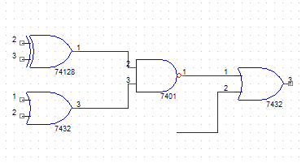
Q1 c)
a’b’ +ab
((a’b’ +ab)(c+d))’
a
F= (a’b’+ab)’+ (c+d)’ + d
((a’b’ +ab)(c+d))’+d
b
= ab’ + a’b + c’d’+ d
= a+ b+c’d’
c
d
d

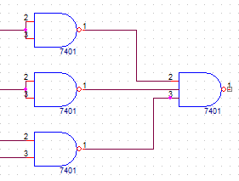
a
Assuming double rail (a+b+c’d’)’’=(a’b’c’d’)’
d’
c’
b
F

Alternate for Q1 a)
= A’B’CD’ + AC’D’ + ABC’ +AB’C + AB’C + BC’D
= A’B’CD’ + (C’D’ + BC’ + B’C)A + BC’D
= A(CC’+B’C) + BC’D + A’B’CD’
= AC’D’ +A’B’CD’ +AB’C +BC’D
= AC’D’ + B’CD’+AB’C + BC’D
Q2 a)
- Prime Implicant PI₁=∑_{m} (0,1,2,3,4,5,6,7) = A’
PI₂= ∑_{m} (4,5,6,7,12,13,14,15) = B
PI₃=∑_{m} (0,2,4,6,8,10,12,14) = D’

AB CD | 00 | 01 | 11 | 10
00 | X | X | X | X
01 | 1 | 1 | X
11 | 1 | 1 | 1
10 | 1 | 1 | 1 | X
F=A’+B

- EPI = PI₁ & PI₂
- F’= AB’
F = (AB’)’
Assume double rail

AB CD | 00 | 01 | 11 | 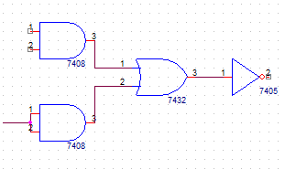  10  A  B’
00 | X | X | X | X
01 |  |  | X | 1
11 |  |  |  | 1  0
10 | X |  |  | X

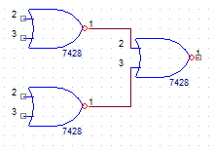
Q2 b) Assume double rail
B
F= B(C’+D’)
0
F=(B+0)(C’+D’)
F=((B+0)’+(C’+D’)’)’
AB CD | 00 | 01 | 11 | 10  C’  D’
00 | 0 | X | X | 0
01 | 0 |  | X | 0
11 | X | 0 | 0 | 0
10 | X |  |  | X

_{F = (F1F2) + F3} i.e. remove m3 & add m9; F= F1m3’ + m0

AB CD | 00 | 01 | 11 | 10
00 | X | X | X | X
01 | 1 | 1 | X | X
11 | 0 | 1 | 0 | X
10 | X | 1 |  | X

F₂=B+C’
AB CD | 00 | 01 | 11 | 10
00 | X | X | X | X
01 | X | X | X | 1
11 | X | X | X | 0
10 | X | X | X | X

F₃=C’

F = F(B+C’) + C’
F= FB +C’

 |  | ab = 00 | ab = 01 |  |  | ab = 10
 |  | 20ns | 20ns |  |  | 20ns
 | a
 | b
 | a'
 |  |  |  |  |  | 2 |  |  |  | Inv 2ns
 | b' |  |  |  |  |  |  |  |  | AND 6ns
(ab')' |  |  | 2 |  |  | 2 |  |  |  | NAND 5ns
a'+b | F1 |  |  |  |  |  |  |  | F1 | OR 8ns
 |  |  |  |  |  | <-2-> | <--5-->
a'b | F2 |  |  |  |  |  |  |  | F2
 |  |  | 6ns |  |  | 6ns
F1+F2 | F |  |  |  |  |  |  |  | F1+F2
 |  |  |  |  |  | <------7------> |  | <--8-->

