ELEC516 Digital VLSI System Design and Design Automation

(Spring, 2010)

Assignment 2

Due Date: 15/03/2010

Assignment 2(A): High Level Simulation and Synthesis

Objective
This assignment will guide you to be familiar with Design Analyzer for analyzing source files and VHDL simulator for high level functional simulation, carrying out synthesis from VHDL source code and verifying the design through gate level simulation.

Hand In

There are 7 questions in part(A), and only one question in part(B), please hand in a report answering the questions and some copies of your waveforms. schematic and layout.

Introduction
In this assignment, you are provided with the following,
- VHDL source code for a 4-bit array multiplier (array_mult.vhd)
- VHDL source code for a halfadder(halfadder.vhd)
- VHDL source code for a fulladder(fulladder.vhd)
- VHDL testbench file (array_mult.vhd)
- VHDL configuration file (cfg_array_mult.vhd)
- Test vector file for the adder (expect_vector)
You will be shown how to analyze and elaborate the adder source code in the Design Analyzer and how to analyze the testbench file, configuration file using VHDL Analyzer. By using the testbench file, configuration file and test vector for the adder, you can do a high level functional simulation for the array multiplier in VHDL simulator, VirSim. Then you have to use the analyzed result for high level functional simulation and synthesis. Since this is your first assignment, this document will guide you through how to use the tools to achieve your goal.

Background for Design Analyzer

Different Views of Design under Design Analyzer
Design Analyzer uses four different views of design, Design View, Hierarchy View, Symbol View and Schematic View. The four views let designer to check their design from different point of view as shown in the following.
- Design View

Shows all designs and sub-designs in memory. It is the initial view of the Design Analyzer. The designs are shown in icon. From the design view, the user can select a design for exploration or for setting design attributes and constraints.
- Symbol View
Shows a design as a black box with input and output ports. From this view, the user can set attributes and constraints for a design and its ports. Attributes specify design-specific information such as the arrival times and strengths of input signals.
- Hierarchy View
Shows a design as a set of one or more named sub-designs. The view displays all the sub-designs in one level of a design hierarchy. The user can move up and down the levels of hierarchy. From the view, the user can see the relationship between levels of a design and work with the individual sub-designs.
- Schematic View
Shows a design as a schematic composed of instances, nets, and ports. An instance in a schematic can be sub-designs.

Note that on the left region of each view’s window, there are six buttons. Theses six buttons are used to transverse between different views. The figure below summarizes how to transverse between different views, after select the sub-design you want.

Design View

Hierarchy View

Schematic View

Symbol View

Background for Testbench
Testbench is a model that is used to exercise and verify the correctness of a hardware model. A testbench has three main purposes,
- To generate stimulus for simulation. The stimulus is usually read from a text file.
- To apply this stimulus to the entity under test and collect the output responses.
- To compare output responses with expected values.
A testbench usually contains four files,
- Test vector file which contains input stimulus, one line for each simulation cycle.
- Testbench VHDL file to read input stimulus and apply this stimulus to entity component under test, compare simulated output with expected output and summarize all output conflict to another text file.
- VHDL source file for the entity component under test.
- VHDL configuration file for binding.

The following shows the relationship between each file,

Background on VHDL Analyzer
VHDL Analyzer compiles VHDL source file and places intermediate files for each design unit in the design library mapped to the logical library name WORK. The analyzer can also generate a listing file that merges the source text with any error messages it produces. By default, it generates compiled event code for fast event simulation. Debuggable event code is always generated.

Background on Scirocco and Virsim
VirSim is a modular debug system. VirSim can simultaneously post process multiple data files or run an interactive session using a supported simulator. User can view the results of simulation and the source files used to generate the simulations in VirSim windows. Debug sessions can be saved in a configuration file, allowing the session to be resumed.
- Project Window
The Project Window is used to analyze, elaborate, and simulate VHDL or mixed VHDL and Verilog projects
- Interactive Window
This window is used to interactively control the simulator, send commands to it, and view the output of the simulator and its current state. Besides, it provides menu and tool bar controls, simulation history information, simulator control, and a pane containing pre-defined and user-defined buttons.
- Hierarchy Browser
It is used to locate and select scopes, signals, and ports for use in other windows, such as Waveform window. It works on any one of a number of simultaneously open design hierarchies. By navigating up and down the hierarchy, the user can locate the scopes and signals he want, and then drag them to other panes or windows for viewing or signal selection. Filters allow the user to selectively locate items for display.

Interactive Window

Hierarchy Browser

Waveform Window
- Waveform Window
The window graphically displays signal waveforms over and within simulation time. The features let the user view and manipulate waveform data. For example, cursors and markers are used to find waveform edges and mark events so that the user can return to them later in the debug session. Specific events may be located by constructing expressions for use as breakpoints. Vectors can be expanded to show individual components.
- Source Window
The window displays the source code for the complete design and traces the behavior of statement execution. The HDL are concurrent modeling language. Therefore, the window is designed to display concurrent statement execution.

Assignment flow
- High Level Simulation, also call pre simulation (vhdlan, scs)
- Debug the pre simulation result (scirocco)
- Synthesize (design_analyzer)
- Post Simulation (vhdlan, scs)
- Debug the post simulation result (scirocco)
Software and hardware requirement (read Appendix A for detail):
If you do the lab with PC, you need to install software Xwin and SSH or X-Manager. Xwin and SSH are pre-installed in all the PCs in Rm.3119.
No specific requirement if you do the lab in Rm.3114(A) with workstation.
High Level Simulation

Setting up the environment for the Synopsys tools
- Source the Synopsys Enviroment cshrc file as the following if you did not include it in the .cshrc_user file.
>source /usr/eelocal/synopsys/courses/.cshrc

You can use following commands to check the version of Synopsys tools
>which vhdlan, >which scirocco, >which design_analyzer, etc
The message outputs should be as follows
/usr/eelocal/synopsys/vcs_mx7.2/bin/scirocco
/usr/eelocal/synopsys/vcs_mx7.2/bin/vhdlan
/usr/eelocal/synopsys/syn-w2004.12-sp2/sparcOS5/syn/bin/design_analyzer
Notes: You may want to put the above command into your own .user_cshrc so that you do not need to type the above command every time you login to a new machine or invoking other terminalsIf you use PC to do the assignment, make sure you have open X-Win and write down the following command, so that the active window could be displayed on your PC.
>setenv DISPLAY your_ip_address:0.0
- Copy the template directory to your home directory
>cp -r /staff/ee/dept/public/elec516/template_vtvt ~/elec516
There are totally three sub-directories in the template directory, “cadence”, “encounter” and “synopsys”.

High Level Simulation example (4-bit Array multiplier)
- Analyze the design
  - Under your directory, copy files needed for this simulation example
>cp –r /staff/ee/qianzl/public/vhdl ~/elec516/synopsys/
  - Design Hierarchy
Several files are copied to the folder “/vhdl/”,we are going to simulate an 4-bit array multiplier and synthesize this design. The top design is array_mult.vhd, where we use bottom design halfadder and fulladder, therefore during analyzer we should analyze these two bottom designs first.
The file cfg_array_mult is the configuration file of the design, which is used to define which architecture of tb_array_mult and array_mult to be used for the design. Later we will see that after synthesis, there will be another architecture named syn_arc of array_mult which is generated from the schematic, then the use of configuration file will be obvious. But notice that we do not have a configuration here for the bottom design halfadder and fulladder, as we will analyze these two entities first, the upper design will use the newest compiled architecture of them.
configuration cfg_array_mult of tb_array_mult is
for TESTBENCH
for UUT: array_mult
use entity WORK.array_mult(arc);
end for;
end for;
end cfg_array_mult;

tb_array_mult(TESTBENCH) is used to describe how to feed the test vector into your design array_mult for simulation and also check the results with the expected results, you can see the file named “error_vector” after simulation if there is any error.
ADDER_4 is the design we try to write in VHDL and to be tested.
  - Go to “~/elec516 /synopsys/sim” directory and execute following unix commands to analyze VHDL source code. The order of the files to be analyzed should be as following from the bottom of the hierarchy of the design.
>cd ~/elec516_lab1/synopsys/sim
>vhdlan -nc ../vhdl/halfadder.vhd
>vhdlan -nc ../vhdl/fulladder.vhd
>vhdlan -nc ../vhdl/array_mult.vhd
>vhdlan -nc ../vhdl/tb_array_mult.vhd
>vhdlan -nc ../vhdl/cfg_array_mult.vhd

Please check if there is any error or warning after you execute each unix command.
Note: The command ‘vhdlan’ will check syntax error of VHDL source codes and translate them into the intermediate files to be readable for the Synopsys tools. You can find files *.mra, *.sim files created after analyzing the VHDL source code. *.mra kept the record for most recently analysis. *.sim files are necessary for simulation purpose.
- Compile and Elaborate the Design
  - Execute unix command to compile and elaborate the design
>scs -nc cfg_array_mult
Note: This command will take a little bit longer to complete. Please check if there is any error or warning after executing the command.
- Simulate the design
  - edit a file named run.sim and type in the following content
run
quit
  - execute following command to simulate the design
>scsim -nc -include run.sim
- Debug your design in GUI
In this session, you are going to check the waveform and debug your design in graphic mode.
  - Execute command ‘scirocco’ to open VHDL Simulator
>scirocco &
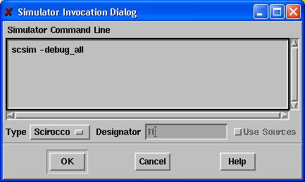
Type in ‘scsim -debug_all’ to open the simulator in debug mode (in debug mode you can use ‘step’ or ‘next’ to simulate your design line by line) and then click ok.

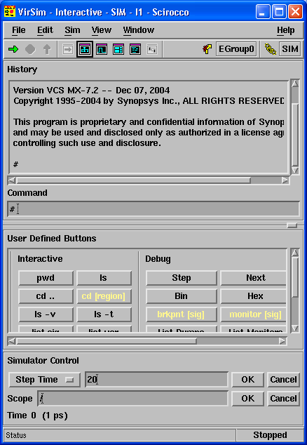
Check the History window if there any warning or error when you open the simulator.

  - In the VirSim-Interactive window, click Window -> Hierarchy
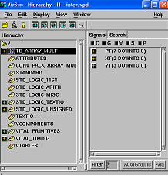
The Hierarchy window shows you the module instance identifiers in the design hierarchy and the nets and registers in these instances. The window has three panes:
- The Hierarchy pane in which you can reveal the module instances that are below the instances already displayed in this pane and then close the display of these revealed instances.
- The Search pane that allows you to search for signals and scopes in your design and displays these search results in this pane so that you can drag and drop (use middle mouse button or both mouse button) them into other windows.
- The Signal Select pane that shows you the nets and registers in an instance so that you can perform simulation operations on them in other windows. These operations would be things like setting a breakpoint so that the simulator halts when a net or register changes value.
  - In the VirSim-Interactive window, click Window -> Waveform
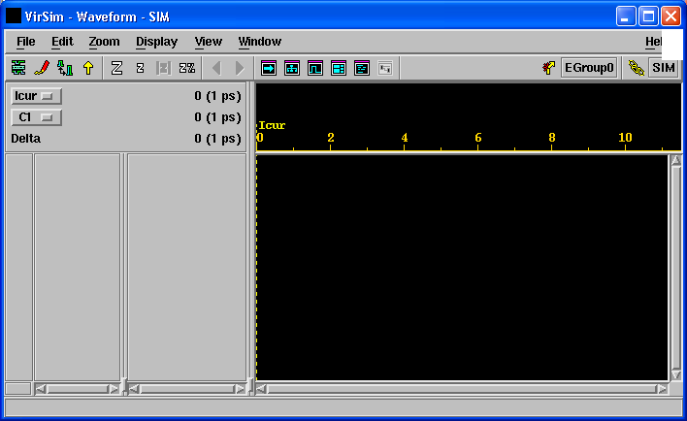
In order to add signals into the Waveform window, you need to select these signals in the Hierarchy window.

In the Hierarchy window, click TB_ARRAY_MULT and then select signals XT
Click Add at the right bottom corner the Hierarchy window.
Use the same way to add other signals YT,PT into the Waveform window.
In VirSim-Interactive window, simulator control area, type in step time 3073000. (The unit for time is ps and it is defined in simulation library, or you can redefine it when you start the VirSim). then click OK. Now, you can check the simulation result in the Waveform window.

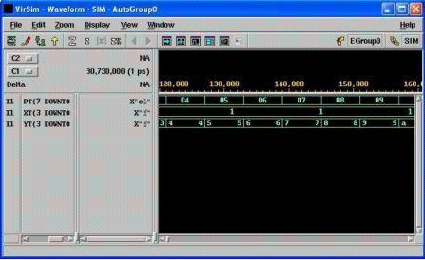

If necessary, you can open more than one waveform window to monitor different set of signals.
To open the Source window you can click Windows -> Source in the Hierarchy window.
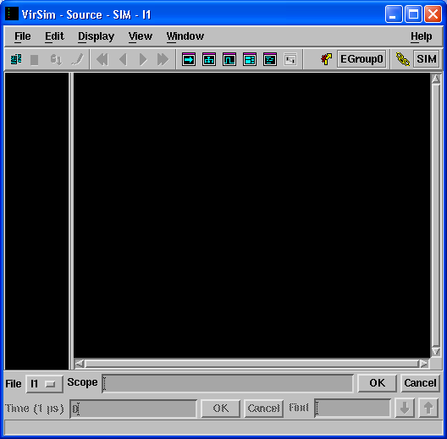

There are more than one way to add the source code into the Source window.
- The most simplest way is in the Hierarchy window, use middle button of mouse (in case your mouse does not have middle button, you should set the xwin to simulate the middle button by press two mouse buttons at the same time) drag and drop the TB_ARRAY_MULT into the Source window.
- Or you can press the first icon in the mane bar to open the source code.

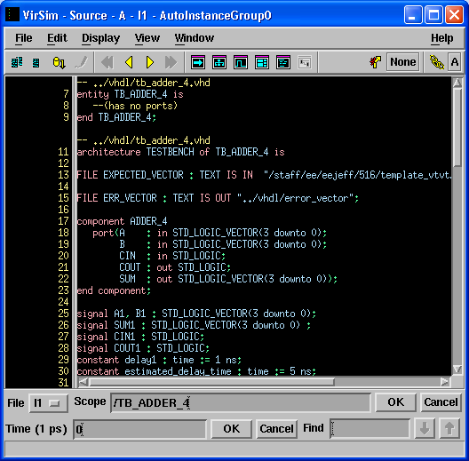

Restart simulation:
In VirSim-Interactive window, click Sim -> Re-exec or Sim -> Invoke Sim.
You can try to simulate up to 30730 ps first, and then use Step or Next in User defined Button area to run the simulation step by step. You can find the arrow in VirSim-Source window move one step when you click Step button once, and you can also find the waveform move one unit time step when you keep clicking Step button or Next button.
Type ‘scsim -debug_all’ in the window above.
Click OK.

Question 1: What files are created after you run scs to compile the CFG file?
Question 2: Notice that in the source window, there are some lines with the green spot and some without. Why? Will the arrow (current line) point to those without green spot when you step the simulation in the interactive window?
Question 3: Explore the ways to use break point in source window. Also explore the way to use cursors to perform measurement.

Synthesis of a 4-bit Array Multiplier
In this part, you have to analyze, elaborate and synthesize the 4-bit array multiplier which you have behaviorally simulated before using design analyzer. In the synthesis process, you have to set the operating environment for your design. In order to match different design goals (power, area, timing), you can set different constrains before synthesis to optimize your design goal. The synthesis process is associated to a cell library. After synthesis, you will generate schematics and symbols for your design. Then, you need to simulate your synthesized design in gate level.
(refer to Appendix B for background of synthesis)
- Invoke Design Analyzer under directory ~/elec516_lab1/sysnopsys/syn
  - Type “ >design_analyzer & ”
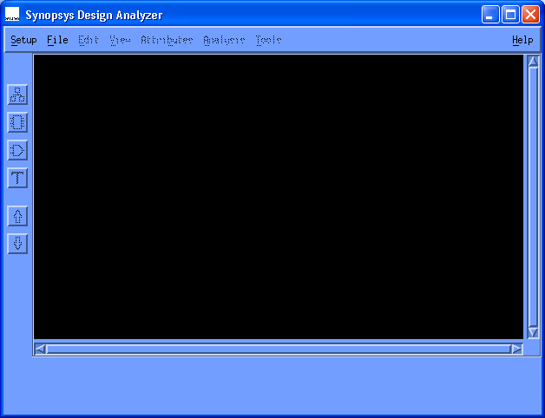
- Check if you open the design_analyzer in the right directory.
In Design Analyzer window, click Setup -> Defaults
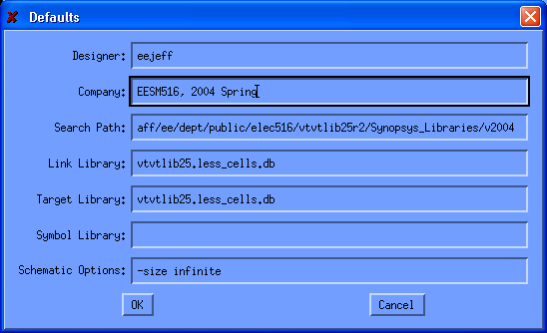
Normally, can see a setting similar to box above, in case you see something like your_library.* in the box, that means you open the ‘design_analyzer’ in a wrong directory.
- Start command window
  - Click Setup -> Command Window
The command window shows all the commands executed in the design analyzer and their results. You should have a look on command window for every operation you have done in the design analyzer.

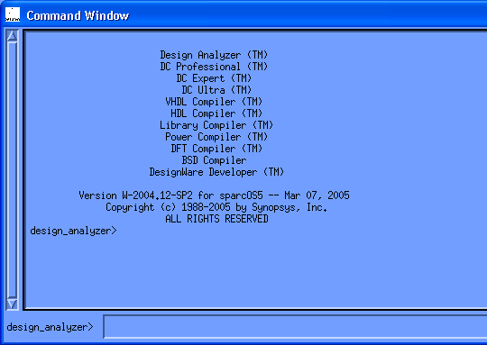
- Analyze 4-bit Ripple Carry Adder (RCA) VHDL source file
  - Click File -> Analyze…
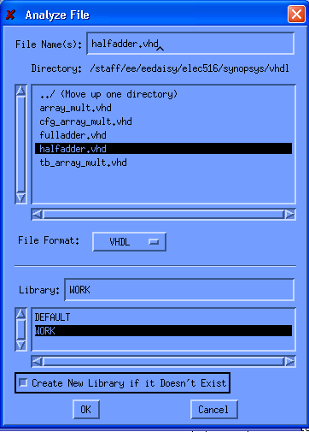
  - Open “VHDL” directory in the upper folder
  - Select “halfadder.vhd”
  - Check “Create New Library if it Doesn’t Exist”
  - Click “OK”
  - Check in the command window or the Analyze pop-up window if there’s any error or warning. Return code 1 is expected.
Use the same steps to analyze fulladder and array_mult
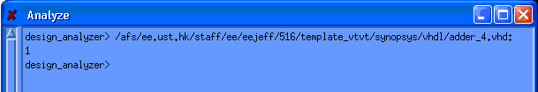

  - Resolve those errors and warnings if there’s any before proceeding
- Elaborate design
  - Click File -> Elaborate…
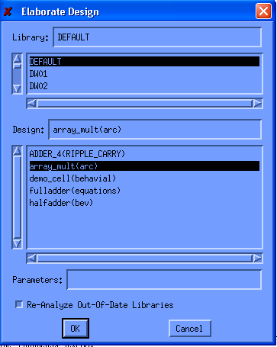
  - Select “WORK” or “DEFAULT” in the Library
  - Select “array_mult(arc)”in the Design
  - Check “Re-Analyze Out-of-Date Libraries”
  - Notice that if the design require generic mapping, the parameters are inputted at the “Parameters” text box
  - Click “OK”
  - Check in the command window or the Elaborate pop-up window if there’s any warnings or errors. Return code 1 should appear
  - After elaboration, three design icons array_mult,fulladder and halfadder will appear in the design view window
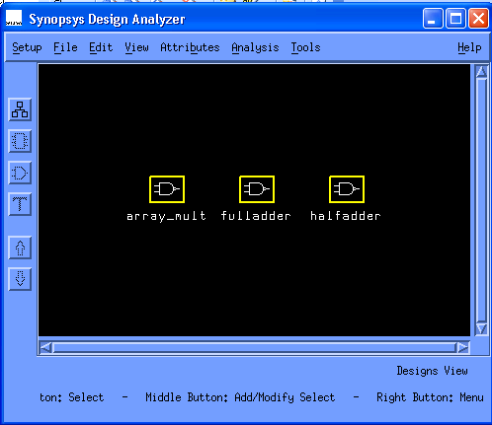
Analyze and Elaborate are always used together to read in VHDL design files. The Analyze command reads a VHDL file, checks for proper syntax and synthesizable logic, and stores the design in intermediate format. Use Analyze to read in each sub-design as well as the top level of the design hierarchy. The Elaborate command creates a design from the intermediate format produced by Analyze. The elaborate command replaces the HDL operators in the design with synthetic operators and determines the correct bus sizes. Use Elaborate on the top level and on sub-designs to which need passing parameters
- Link design
Link design is to check if all the data for design exist or is reachable, if it returns some instance which is unsolved, it means the instance is missed. This operation will first try to find the design in the memory (actually, all the data stored in the memory is shown in the Design Analyzer window), then find the working directory and finally find the libraries path setting in the setup file.
  - Click and select array_mult icon
  - Click Analysis -> Link Design…
  - Leave everything as default
  - Click “OK”
Return code 1 is expected.
- Check Design
  - Click Analysis -> Check Design…
  - Leave everything as default
  - Click “OK”
  - Check if there are any warnings and errors. A return code 1 is expected.
- Save design before synthesis
  - Click File -> Save as…
  - Open “db” directory
  - Type “array_mult_before_compile.db” in the File Name
  - Check “Save All Designs in Hierarchy”
  - Click “OK”

Setting Operating Environment
- Set Input Driving Strength
  - In symbol view of array_mult, select one of the inputs
  - Click Attributes -> Operating Environment -> Drive Strength…
  - Type “50” for both Rise Strength and Fall Strength.
The time unit for rising and falling transition delay is ‘ps’.
  - Click “Apply”
  - Repeat for other inputs
- Set Output Capacitance Load and Fanout Load
  - In symbol view of array_mults, select one of the outputs
  - Click Attributes -> Operating Environment -> Load…
  - Type “100” in Capacitive Load. The unit for cap load is ‘ff’.
  - Click “Apply”
  - Repeat for other inputs

Setting Design Constraints (Timing)
- Define Virtual Clock
  - De-select any input/output port
  - Click Attribute -> Clocks -> Specify…
  - Clock name: “vclk”
  - Period: “10000” (10ns)
  - Uncheck “Fix Hold” and “Don’t Touch Network”
  - Click “Apply”
Notes: Virtual clock is not a real input for the design. It is for synthesizing purpose; it is reference timing information for you to set input delay, output delay and delay for your design.
- Define Input Arrival Time (Relative to vclk)
  - Select one of the inputs
  - Click Attribute -> Operating Environment -> Input Delay…
  - Relative to Clock: “vclk”
  - Max Rise, Max Fall, Min Rise, Min Fall: 0 (0ns)
  - Click “Apply”
  - Repeat for other inputs
- Define Output Ready Time (Relative to vclk + T)
  - Select one of the outputs
  - Click Attribute -> Operating Environment -> Output Delay…
  - Relative to Clock: “vclk”
  - Max Rise, Max Fall, Min Rise, Min Fall: 1000.
The time unit is ‘ps’.
  - Click “Apply”
  - Repeat for other outputs
- Setting Optimization Directives
  - Select array_mult icon
  - Click Attributes -> Optimization Directives -> Design…
  - Check “Structure Logic”
  - Check also “Apply timing Driving Structuring”
  - Leave other as default
  - Click “Apply”
- Setting Constraints for timing-critical design
  - Select array_mult icon
  - In command window, type ‘set_max_delay 0 –from all_inputs()’ and then press enter
Note: in case you want minimum area for design, you can execute following command in command window, ‘set_max_area 0’. Every time when you change from timing critical to area critical, you need to remove the constraints and re-do from the step 15.
- Save Design before Compilation
  - Select array_mult icon
  - Click File -> Save as…
  - Open “db” directory
  - Save as “array_mult_min_time_before_compile”
  - Check “Save All Designs in Hierarchy”
  - Click “OK”
The relationship between the input delay , output delay and target circuit delay can be expressed in the following figure.

Register
Target Circuit
Register
vclk
Input Delay
Output Delay
1 clock cycle
Target Delay

Carrying out Synthesis
- Perform Synthesis
  - Select array_mult icon
  - Click Tools -> Design Optimization…
  - Check “Map Design” also “High” Map Effort
  - Check “Verify Design” also “High” Verify Effort
  - Check “Allow Boundary Optimization”
  - Click “OK”
- Save Synthesized Design
  - Select array_mult icon
  - Click File -> Save as…
  - Open “db” directory
  - Save as “array_mult_min_time_after_compile.db”

Question 4: Compare the schematic view before and after compilation. Is there any difference? Are the gates numbers the same? How about the name of the gates?

Analysis of Synthesized Result
- Critical Path Timing(max)
  - In the schematic view, click Analysis -> Highlight -> Critical path, the critical path is highlighted
  - In the command window, type “ report_timing –delay max –max_paths 10” to observe the 10 maximum delay paths in our design in the command window.
- Reporting
  - Click Analysis -> Report…
  - Check “Area” and “Timing”
  - Click “Apply”

Question 5: Capture the schematic for both design constraints (timing critical and area critical). Report the critical path delay and area for both design constraints.

Gate Level Back Annotation
- Export the Design in VHDL
  - Select array_mult icon
  - In the command window, execute the following commands
change_names –rule vhdl -hierarchy
write –format vhdl –hierarchy –output ../vhdl/array_mult_compiled.vhd
  - Go to the directory “vhdl/”, check the file “array_mult_compiled.vhd”. Is there any difference from the original source file?
In these steps, we export the synthesized design in VHDL format which is in gate level. Then we repeat the past steps to run gate level simulation as follows.
- Create the Configuration File
  - Copy the old configuration file to “cfg_array_mult_compiled.vhd”
  - replace the array_mult(arc) by array_mult(SYN_arc)
  - Save the new configuration file
- Now you need to repeat the step 3 to step 6 with new VHDL files.But you don’t have to analyze the halfadder and fulladder this time
  - enter “sim” directory
  - array_mult_compiled.vhd, tb_array_mult.vhd, cfg_array_mult_compiled.vhd
  - Compile the CFG file
- Repeat step 6 to view the waveform for post simulation.
The SYN_arc architecture in file array_mult_compiled.vhd is automatically generated in Design Analyzer. The Design Analyzer will read in the design with the architecture name (arc). After synthesis, the Design Analyzer will add the SYN_ in front of the original architecture name.

Question 6: For timing critical synthesis, capture the waveform for both pre-simulation and post-simulation then describe the difference between two results and explain what makes the difference?

Question 7: Explore the Design Space by Using Design Analyzer: Re-synthesis the design from “array_mult_before_compile.db” with other constraints other than timing critical and area critical. E.g. change the period of virtual clock, input delay, output delay, maximum area or maximum delay, etc. You should have at least three synthesized designs finally. Plot the area vs. delay curve to see the tradeoff between the parameters. You are allowed to use any options in the design analyzer.

ELEC516 Digital VLSI System Design and Design Automation (Spring, 2010)

Assignment 2(B): Auto Place and Route in Encounter
- Go to directory “syn” and open design analyzer
  - Open the saved design adder_4_min_time_after_compile.db from “File→ Read”.
  - In the command window, execute the following commands
change_names –rule verilog -hierarchy
write –format verilog –hierarchy –output ../vhdl/array_mult_compiled.v
In this step, you export the design in verilog format. The verilog file is used to place and route the design because the tool encounter only accepts verilog netlist.
Go to directory “encounter”
- Source the Encounter tools as following if you did not include it in the .cshrc_user file.
  - >source /usr/eelocal/cadence/ic5141a/.cshrc
  - >source /usr/eelocal/cadence/soc52/.cshrc
  - open the Encounter
>encounter
Note: Don’t add mark ‘&’ after encounter, so that the UNIX shell will be Encounter console.
- Click Design → Design Import
- Following the following step add the array_mult_compiled.v into the list of Verilog
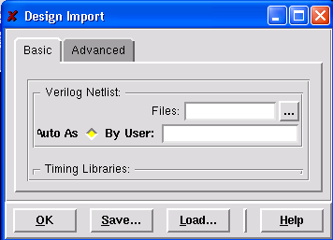
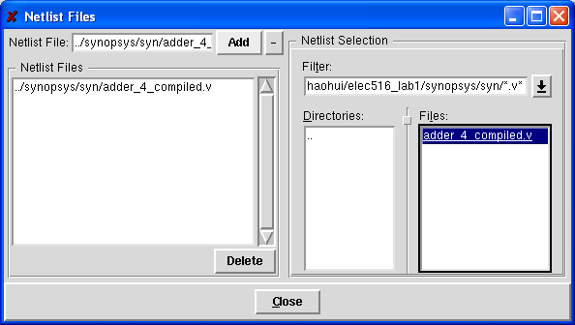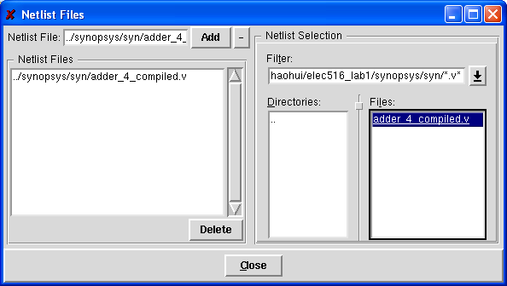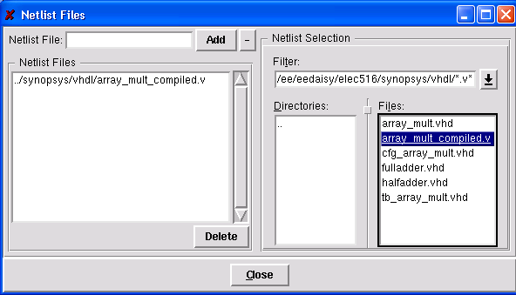
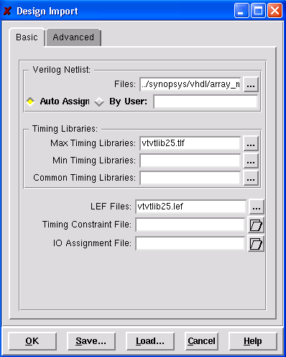

Power
After successfully import the design into Encounter, the green box will appear.
Use the same way to fill in the LEF Files, Max Timing Libraries fields and check
Top Cell for Auto Assign.
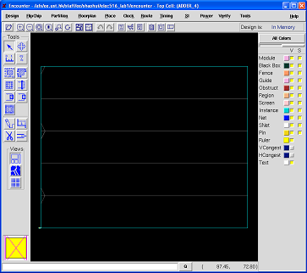

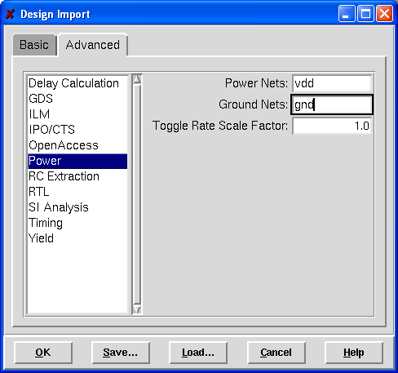

Change to Advanced Tap, and fill in vdd for Power Nets and gnd for Ground Nets.
Then click OK.

- Click Floorplan – specify floorplan 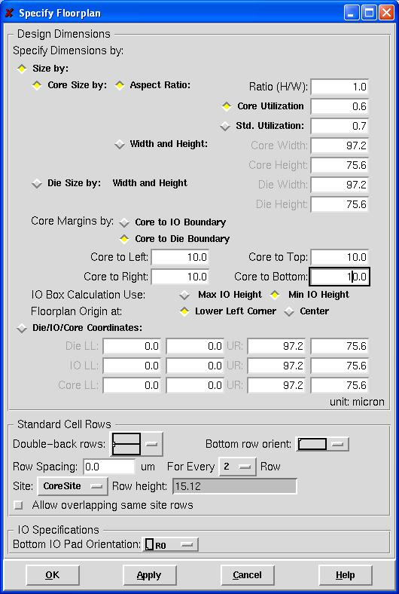>

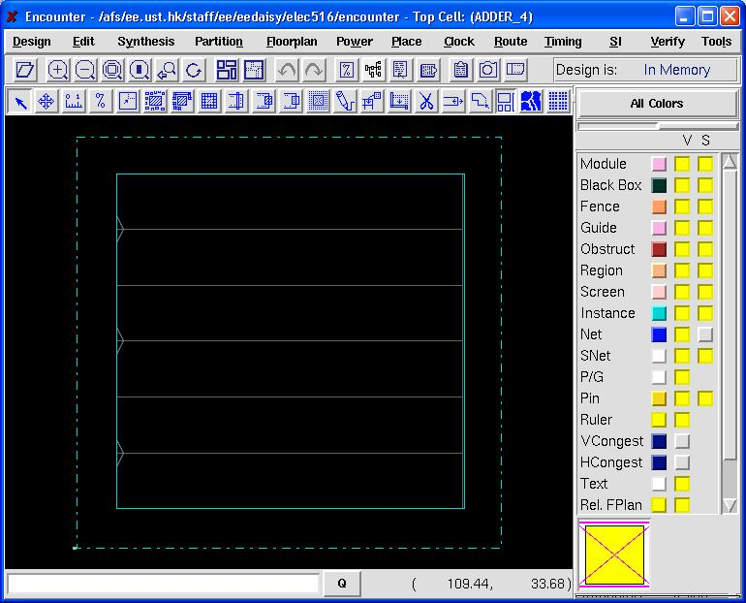

- Global Connection
  - Click Floorplan→ Connect Net Connections..
  - Following the setting listed in the table below and add the connects to the list
  - Click Apply, and then Check. The Check command check for unconnected pins in your design. Verify and fix if any warnings or errors appear in the encounter console.
Setting | Setting1 | Setting2 | Setting 3 | Setting 4 | Setting 5
Connect Region | Pins: vdd | Tie High | Pins: gnd | Tie Low | Pins: vss
Scope Region | Apply All | Apply All | Apply All | Apply All | Apply All
To Global Net | vdd | vdd | gnd | gnd | gnd

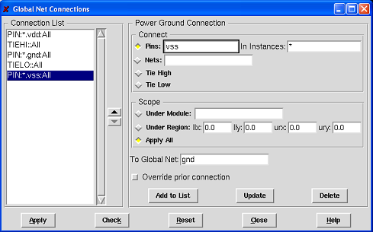

Click Power→ Power Planning → Add Rings

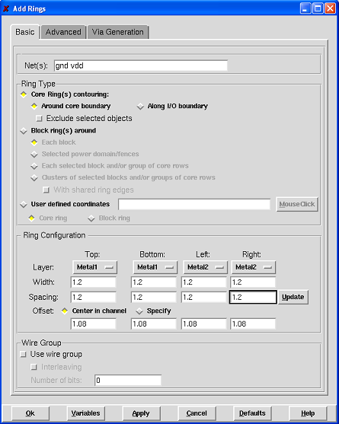
In the Ring Configuration box, change the Width and Spacing to 1.2um and check Offset to Center in Channel.

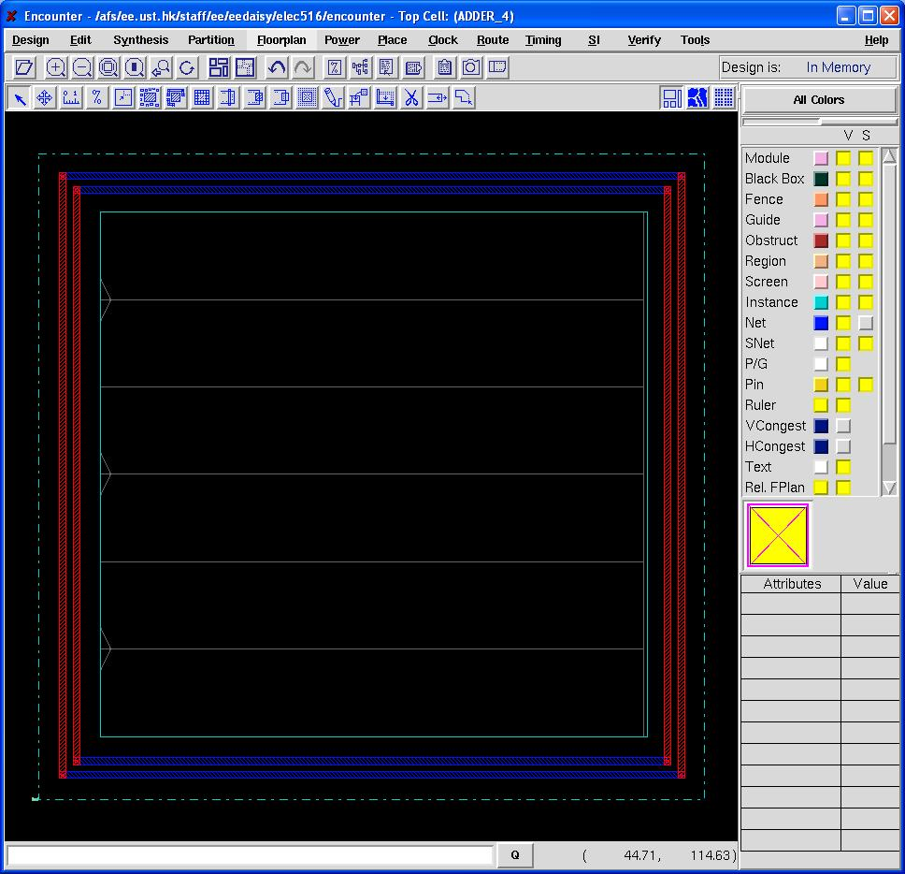

Power → Power Planning → Add Stripes

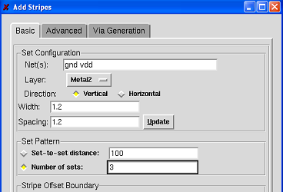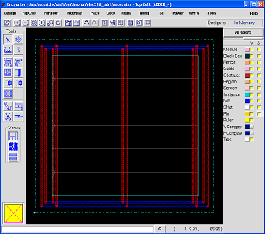

Click sroute→special route, leave everything default and click ok.

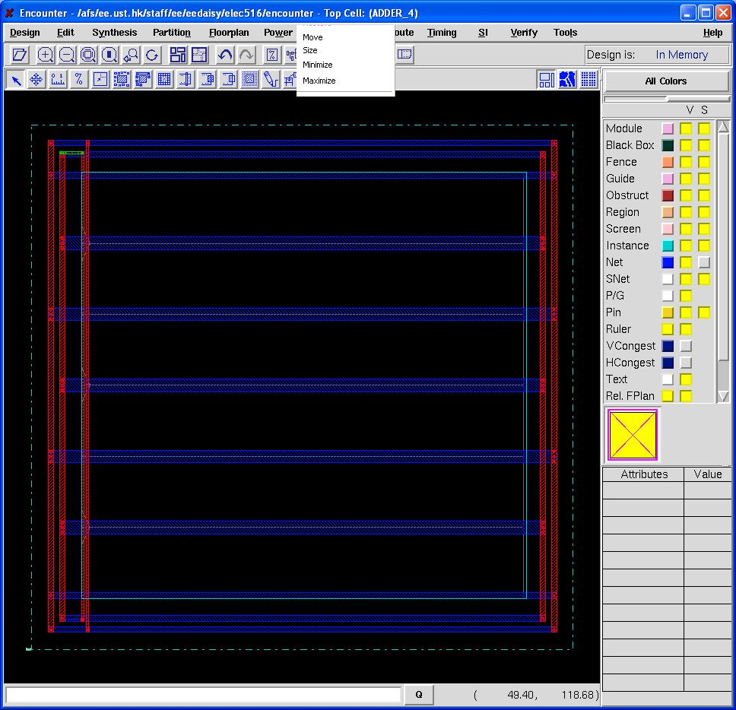

Click Place → Standard cells and blocks, check the options as the figure shows. Be sure not to include any optimization step when placing and routing.

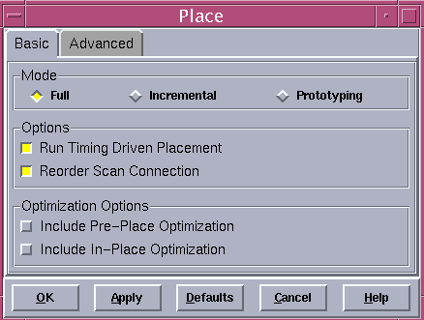

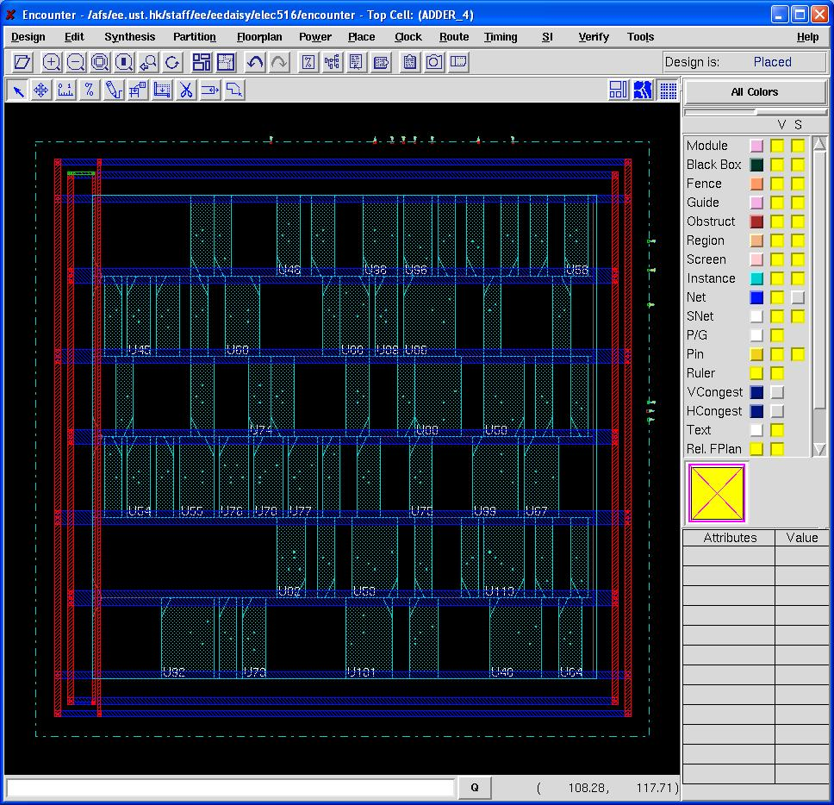

Click Place -> Filler -> Add Filler..

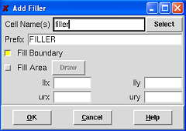
Write “filler” in the Cell Name(s)

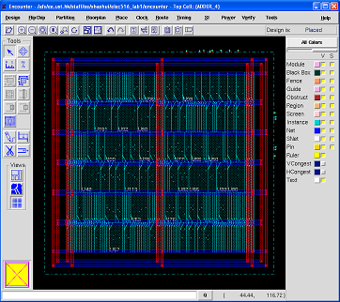

Click Route → WRoute, leave everything as default and click OK

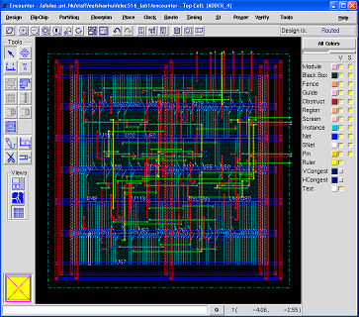

Well done!!
- You have finished the auto place and route in Encounter. Now you are going to verify any mistake in the layout.
  - Click Verify → Verify Connectivity, leave everything as default and select OK.
  - Check the Encounter console if there any error or warning in connectivity.

Following is the sample console output for connectivity checking.

Click Verify → Geometry, leave everything as default and select OK. Following is the sample console output.
******** Start: VERIFY CONNECTIVITY ********
Start Time: Sat Sep 15 23:45:37 2007

Design Name: array_mult
Database Units: 100
Design Boundary: (0.0000, 0.0000) (168.1400, 126.6400)
Error Limit = 1000; Warning Limit = 50
Check all nets

Begin Summary
Found no problems or warnings.
End Summary

End Time: Sat Sep 15 23:45:37 2007
******** End: VERIFY CONNECTIVITY ********
Verification Complete : 0 Viols. 0 Wrngs.
(CPU Time: 0:00:00.0 MEM: 0.000M)

Verification Complete : 0 Viols. 0 Wrngs.

**********End: VERIFY GEOMETRY**********
*** verify geometry (CPU: 0:00:00.2 MEM: 11.4M)

Next step you are going to extract the routing timing information and back annotate into Design Analzer to find the critical path delay with routing information and back annotate into Scirrocco to perform the post layout simulation.

Routing Delay Information Extraction:
- Click Timing → Extract RC and the select OK

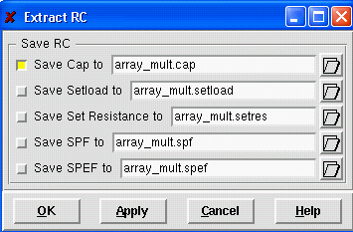

Check the Encounter Console output
encounter 1> RC Extraction for instance array_mult
RCMode: Default
Capacitance Scaling Factor : 1.00000
Coupling Cap. Scaling Factor : 1.00000
Resistance Scaling Factor : 1.00000
Shrink Factor : 1.00000
Default RC extraction is honoring NDR/Shielding/ExtraSpace for clock nets.
Using detail cap. scale factor for clock nets.
RC Extraction Completed (CPU Time= 0:00:00.0 MEM= 201.2M)

Click Timing → Calculate Delay, then select OK

Click Timing->calculate delay, then click ok.
encounter 1> RC Extraction for instance array_mult
RCMode: Default
Capacitance Scaling Factor : 1.00000
Coupling Cap. Scaling Factor : 1.00000
Resistance Scaling Factor : 1.00000
Shrink Factor : 1.00000
Default RC extraction is honoring NDR/Shielding/ExtraSpace for clock nets.
Using detail cap. scale factor for clock nets.
RC Extraction Completed (CPU Time= 0:00:00.0 MEM= 201.2M)
encounter 1> delayCal Option : -sdf array_mult.sdf -idealclock
delayCal Mode : setDelayCalMode -default
Topological Sorting (CPU = 0:00:00.0)
Number of Loop : 0
Start delay calculation (mem=201.219M)...
Handling High Fanin Net......
Handling 0 High Fanin Net (CPU = 0:00:00.0)
**WARN: Unable to find and calculate resistance for via M2_M1, assign 4.0 ohms.
**WARN: Unable to find and calculate resistance for via M3_M2, assign 4.0 ohms.
**WARN: Unable to find and calculate resistance for via M4_M3, assign 4.0 ohms.
**WARN: Unable to find and calculate resistance for via M5_M4, assign 4.0 ohms.
.
Printing SDF File.....
Delay calculation completed.
(0:00:00.0 201.219M 0)

Delay Calculation Summary:
Number of nets with pin count greater than 100 : 0
Number of nets using excludenet file : 0
Number of nets using set_resistance : 0
Number of nets using default delay : 0
CPU Time (0:00:00.0)

All the jobs in the Encounter have been done. The routing timing information has been

saved as a file array_mult.sdf in Encounter working directory. Now you are going to back annotate this file into Design Analyzer.
- Click Design → Save Design, save the design as “array_mult.enc”
- Open a new shell or close the Encounter, source the Synopsys .cshrc file.
- Go to directory ‘synopsys/syn’ and open the Design Analyzer.
- Open the saved design “array_mult_min_time_after_compile.db” by “File→Read..”.

Type the following command in the command window

change_names –rule verilog –hierarchy
- If the design hierarchical has several designs, select the top design and click Analysis → Link Design to check if all the sub-blocks and instances have been loaded into the Design Analyzer. Return code ‘1’ is expected. In case there is any message about the unsolved instanced, it means some instances were missed, you need to read these missed instances into Design Analyzer before you move to next step.
- Select the array_mult, click Analysis → Report, check Timing and then click Apply. The report output shows the critical delay without routing information is 3027.47 ps.

- Click Setup → Command window, you need to execute following commands to read in the routing timing information from Encounter

read_sdf ../../encounter/arry_mult.sdf

Return code ‘1’ is expected for reading in the SDF file.
- Select the array_mult icon, Click Analysis → Report to report timing again.

You will find the critical path delay is 3305.91ps now. It is the post layout critical path delay.

Next step we are going to back annotate the SDF file into the Scirocco for the post layout simulation. Because the SDF file from Encounter cannot directly input into Scirocco, you need to write the SDF again from the Design Analyzer.
- Select array_mult icon, and in the Design Analyzer command window execute following command.

change_names –rule vhdl –hierarchy

write_sdf array_mult.sdf

Return code ‘1’ is expected for successfully execute the command. You can open the file array_mult.sdf in directory syn/ and compare the file array_mult.sdf in directory encounter/.

Post Layout Simulation
- Goto ‘synopsys/sim’ directory
- Copy the .sdf file to the sim directory

>cp ../syn/array_mult.sdf ./
- Open Scirocco by typing the following message in the simulator invocation dialog

scsim –debug_all –sdf /tb_array_mult/UUT/:array_mult.sdf

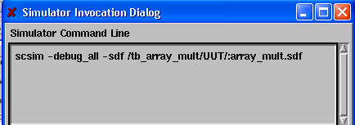

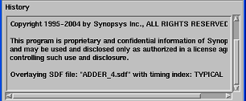

Check the history window in the Scirocco to check if there any error when reading in the SDF file. The figure above shows the example output in the history window

For some design post layout simulation, you may get the following error messages of negedge and posedge, you can just ignore them.

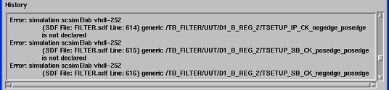

Now in Interactive Window, Click Sim → Invoke Sim, reopen the simulator without SDF file

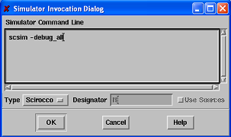

Question B1, copy a picture of your simulation result for post_schematic and post_layout respectively, and compare the waveform at a certain time , tell what’s the difference between them ?

ELEC516 Digital VLSI System Design and Design Automation

(Spring, 2010)

Appendix A: Unix Setup (Modified from ELEC301 Lab. Materials)

Login the EE workstation via PCs (in Rm3119)
Step 1. The EE workstations are using Unix system. You can remotely login the EE workstations. Following the steps below to login the EE workstations via PCs (labs in Rm3119).
  - In the PC, run the X-Win program first, Programs →X-Win32 5.x → X-Win32, then on the screen displayed click on ‘Cancel’.
  - Then, run the SSH Secure Shell program;
In the host name field, type in which EE workstation you are going to login. e.g. eesu9.ee.ust.hk
You can login to 20 EE workstations, they are eesu1 to eesu10, eesu114 to eesu118 and eesu125 to eesu130.

Programs → SSH Secure Shell → Secure Shell Client
Press Enter/Space to connect
Type in your EE account name. Your EE account name is the same as your ITSC account name.

Then click on ‘Connect’. It will then ask you to key in the password. If you are a new EE account user, TA will provide you the password for the first time login.

  - If you login successfully, you will have the display looked like this,
Your EE account name
The EE workstation in use
Type in this command:
“setenv DISPLAY ??????:0.0”,
change ‘??????’ to your PC’s name (or type in the IP address of the PC you’re using). Then, what is running in eesu9 is able to be displayed on your PC.

Basic UNIX Commands
Now you are using the EE workstation which is running under Unix system. The most common UNIX commands are listed below. You should try them out and be familiar with them. If you need help, the UNIXhelp for Users (http://www.ust.hk/itsc/unix/UNIXhelp1.3/Pages/) is useful to you. Or you can use the ‘man’ command to look at the details of each command, e.g. in the command prompt, type in ‘man cp’ (command ‘cp’ is used for copying files), the manual of using ‘cp’ command will then be displayed.
To ... | UNIX command
display user’s account quota | fs lq
display the jobs running in the workstation | top
display a list of files | ls
display all files (including the hidden files) | ls -al
display the content of the file | cat
display files with pauses | more
copy files | cp
rename files | mv
delete files | rm
delete directories | rmdir
create directories | mkdir
change the working directory | cd
print a file | lpr
display the print queue | lpq
remove the print job | lprm

Changing passwords
The passwords for new accounts/users (for EE network) are pre-assigned by the system. In order to minimize password intrusion, after logging in the system for the first time, you are advised to change this password yourself.
  - Activate the console window by clicking on this window using the mouse.
2.2 At the UNIX command prompt, type in "passwd" and press < Enter >.
2.3 Type in your pre-assigned password at the "Old password:" prompt and press < Enter>.
2.4 Type in your new password at the "New password:" prompt and press < Enter >. (your new password should contain 8-14 characters and the word must not be found in a dictionary.)
2.5 Retype your new password again at the "Retype new password:" prompt for verification and then press < Enter >.
  - Your new EE network password is now activated, logout the machine and login again with your new EE network password. If you need assistance please ask TAs for help.

Special files in your EE account; the Auto-execute C-shell Scripts
To list out all files in your EE account, type in ‘ls –al’ at the UNIX command prompt.
The first file to note; File name: .cshrc
This file should NOT be modified. The C-shell executes this file located in user’s home directory each time a new C-shell is invoked, including the login C-shell.
The second file to note; File name: .cshrc_user
This file is executed after executing the .cshrc file. The .cshrc_user file can be modified by the users if necessary. For example, setting up C-shell history, path, prompt and aliases.
Setting up the environment for Running Synopsys Design Analyzer and Encounter
Step 3. We are going to set the environment for running Synopsys Design Analyzer and Encounter.
3.1 Add the following line in your .cshrc_user file by using a text editor.
(e.g to use the Texteditor, type in ‘textedit &’ in the command prompt, or pico, vi, etc)
source /usr/eelocal/cadence/soc3.2/.cshrc
source /usr/eelocal/synopsys/courses/.cshrc
3.2 In order to use this new setup, type the following UNIX command at the UNIX prompt,
>source ~/.cshrc
In the assignment, you are required to copy the elec516_lab1/ folder to your home directory. Actually the folder contains the necessary files for you synthesis, simulation place and routing. Check what file is inside the folder encounter/, synopsys/syn, synopsys/sim by command “ls –al”

More about the EE workstations
The workstations of eesu1 to eesu10 are located in Rm3114A. Instead of remotely connecting to workstations as you did in this lab, you can also directly login the EE workstations in Rm3114(A).

ELEC516 Digital VLSI System Design and Design Automation

(Spring, 2010)

Appendix B: Background of Synthesis
1. Optimization within Design Compiler (Design analyzer)
In VLSI design, usually 3 factors are to be optimized. These 3 factors are area, timing/ performance, power consumption. These 3 factors are in trade-off relationship (i.e. if one factor gets better, others may get worse). You can set design constraints before synthesis to favorite your design goal (any one of the 3 factors). Usually, we set different constraints on timing, optimize and select a better result in area which meets our design goals or vice versa.
- Synthesis and optimization flow summary:
In Design Analyzer, Synthesis and optimization flow includes following steps:
• Specify symbol, link and target library in file: .synopsys_dc.setup;
• Specify library mapping in file: .synopsys_vss.setup
• Analyze and elaborate design source files;
• Link design to resolve design and library component references for the design;
• Check design for obvious errors, such as unconnected ports, cells with no input or output pins, differing pin counts between a named component and its corresponding library component, multiple drivers for a port, or a recursively defined hierarchy.
• Save the design as version l;
• Select Technology model -- select operating condition and wire load model;
• Define operating environment -- input drive strength, output cap. load and fanout load;
• Set design constraints for your design goal -- define reference clock, input delay time, output delay time, point to point timing constraint, area or timing critical, min fault coverage, max area;
• Save the design with constraints as version 2 before optimization. The next time you read this version, the constraints are associated with the design;
• Compile (optimization) based on your design constraints;
• Analyze the timing and area of the synthesized result;
3. What is Operating condition and wire load model
Operating condition and wire load model are modeled inside the technology library. Operating condition includes variables like temperature, supply voltage and manufacturing process. It is usually predefined and group the variables into a set of best-case, worst-case and typical case models. They vary from one library to another.
In the absence of physical routing wire information, Design Compiler uses statistically generated wire load models to estimate wire lengths in a design. The wire load models provided in the technology library define a fanout to length relationship.
4. What is Operating environment
Operating environment includes specifying input drive strength (rise and fall) and output cap. load and fanout load.
Input drive strength and output cap. load unit are predefined in the technology library. It is equivalent to a standard load unit. A blank or zero input drive strength means infinitive drive strength.
Design Compiler adds fanout load value to all other cap. load on the output and tries to make resultant load less than the output’s maximum load capable to drive. Therefore, output fanout load is usually zero (or blank) to avoid overdrive. On the other hand, if you want add some design margin, you can use output fanout load.
5. Design constraints
Design constraints includes define reference clock, input delay time, output delay time, point to
point timing constraint, area or timing critical, min fault coverage, max area.
Design Compiler use defined clock as a reference to measure input delay and output delay time. In sequential circuit, you can define clock source as clock reference. In pure combinational circuits, you can define virtual clock as clock reference. Virtual clock is not associated to any input but you still have to define it (refer to lab procedure for how to do it). After defining clock reference, you can specify input arrival time and expected output delay time. The figure below shows you the relationship between reference clock and input and output delay.
For some sequential circuit, if you want to constrain the point to point delay for particular path of combinational part, you can use point to point constraint provided that it does not conflict with other design constraints.
If you want to take timing as the highest precedence in design constraints, you can specify the reference clock, input delay, expected output delay, enable timing critical, disable area critical, blank
max area
6. How to set design constraints for min. area design goal
Enable area critical, assign a very small value to max area (e.g. 1) and leave all other constraints blank or disabled.
7. Remove all design constraints from a design with constraints setting
In the command window of Design Analyzer, type remove_constraint -all. This is very useful when you want to synthesize same design for different constraints.
8. Three terms to be discussed for synthesis
Terms | Definition | Use | Method
Don’t touch | When you want a subdesign block to remain unchanged during optimization, you can set it don’t touch | For register bank subdesign, improvement in area and timing is little. Make it don’t touch can save synthesis and optimization time | Click the subdesign icon of design/symbol view, then click on  Attribute →Optimization directive →Design  Don’t touch: [enabled]  Click on Apply
Ungroup | When a subdesign is ungrouped, its level of hierarchy is removed and it is merged with the surrounding logic | To combine combinational blocks to minimize redundant logic during optimization | Click the subdesign icon of design/symbol view, then click on  Attribute →Optimization directive →Design  Ungroup: [enabled]  Click on Apply
Uniquify | It creates one copy of the subdesign each time it is referenced in the design, then assigns a unique design name to the copy | When a subdesign block is referenced more than once | Click the top icon of design view, then click on  Edit →Uniquify →Hierarchy  Command window will display which design is uniquified

